* You start with a budget of 100 million
* You select 15 players from a database
* Each player has a value
* You must not go over the 100
* You confirm your team and each week the points are updated
* We need a database of 100 players or so
* Each player has a name, value, position and image, and team
* You can search the database by team, player name or value ranges
* You can enter a league with your friends
* Most points goes on top, easily done with an sql sort like select squad from league sort by points ascending or whatever

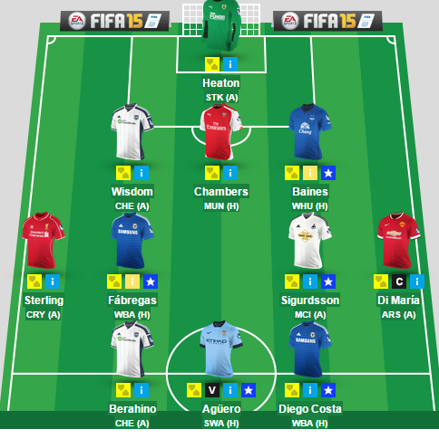

* You would have a view of your team something like this.
* The yellow box can be clicked to remove a player from a team
* When you are ready you click a button to confirm changes
* Otherwise nothing happens

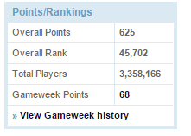

* Your position and points and stuff is shown here



We could show the next set of fixtures coming up.

* The transfer page would have the full database of players
* You can sort by team , or value or position

Each week it would get the scores somehow either we input them or get an RSS feed for them. So a player got a goal he gets 5 points, if he got a point maybe he gets 2 points. He would need a total point’s column in the database

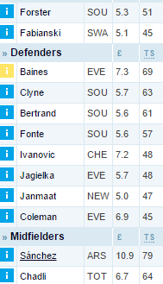

* So here it shows his name, value and total points he has so far

What we definitely need

* A database of players
* Web pages to store all this crap
* The java backend
* Login to web page with php or javascript
* Jquery and stuff for the page
* The social media stuff.

Web pages

* A main page that shows your team and overall score and so on
* A transfers page , mainly sql statements used in here
* A social media page
* Fixtures page
* Blog plugin page
* Tweets page

What we can do before xmas for that clown

* The databases in sql ( estimated time 2-3 days for one person)
* Are we doing that on usb web server I presume we are?
* The web pages with jquery and html
* All the documentation shite
* We need to get a move on clearly. The documentation needs to be apportioned to each person, there’s one large doc we can all do one bit each.
* Someone needs to do the website, Ii would suggest 2 people work on the web site and one the sql
* We need the project diaries done too.
* It also seems we need the prototype doc, we really need the prototype done BEFORE we do this doc, though I would suggest trying to predict what we are going to do and do it as we are also doing the prototype or we have no time left!
* I would not suggest any java before xmas or we will not have time, just the site designed well and the sql, remember we can use a really good responsive jquery template for the site and change it to suit us, make sure it is open source! That saves a lot of time